CST8002 Programming Language Research Project
Evidence of Learning
Submitted By: Samatar Abdullahi,
Student ID: 041198705

Submitted to: Professor Stanley Pieda
in partial fulfillment of the requirements for CST 8002_302

Computer Programming
Algonquin College

Sep 25, 2026

Reasoning:

This report is constructed in order to read data from the given excel file from the vulnut NP dataset. It puts each row in a lakerecord and projects each object to the console.

Dataset and record object:

The columns that the dataset contains are LakeIdentification, ID, Year, Species and species code and percent abundance. My lakerecord class is present in a separate file (record.py rather than main.py). It contains a log of different areas of a excel file.

Program Layout:

Recordobject is in a different file than the main code LakeRecord is in Record.py

File I/O is in open() in loadRecords

Library comes from the CSV file

Record stores all objects

Loop reads rows ,then moves onto the next and displays it
Methods __init__(), display(), load_records(), and main()

Exception handling is FileNotFoundError and OSError handlers

Name is always available at the top of the program.

Program Demo:

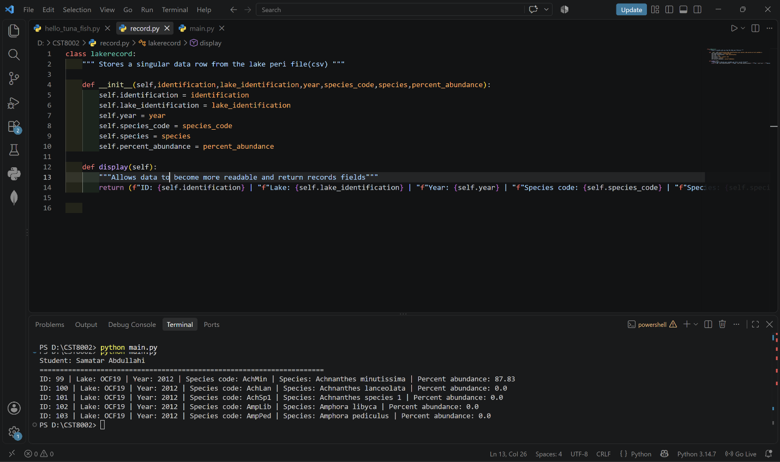
Figure 1. The program displays first 5 data lines of the csv file from the Vulnut NP dataset

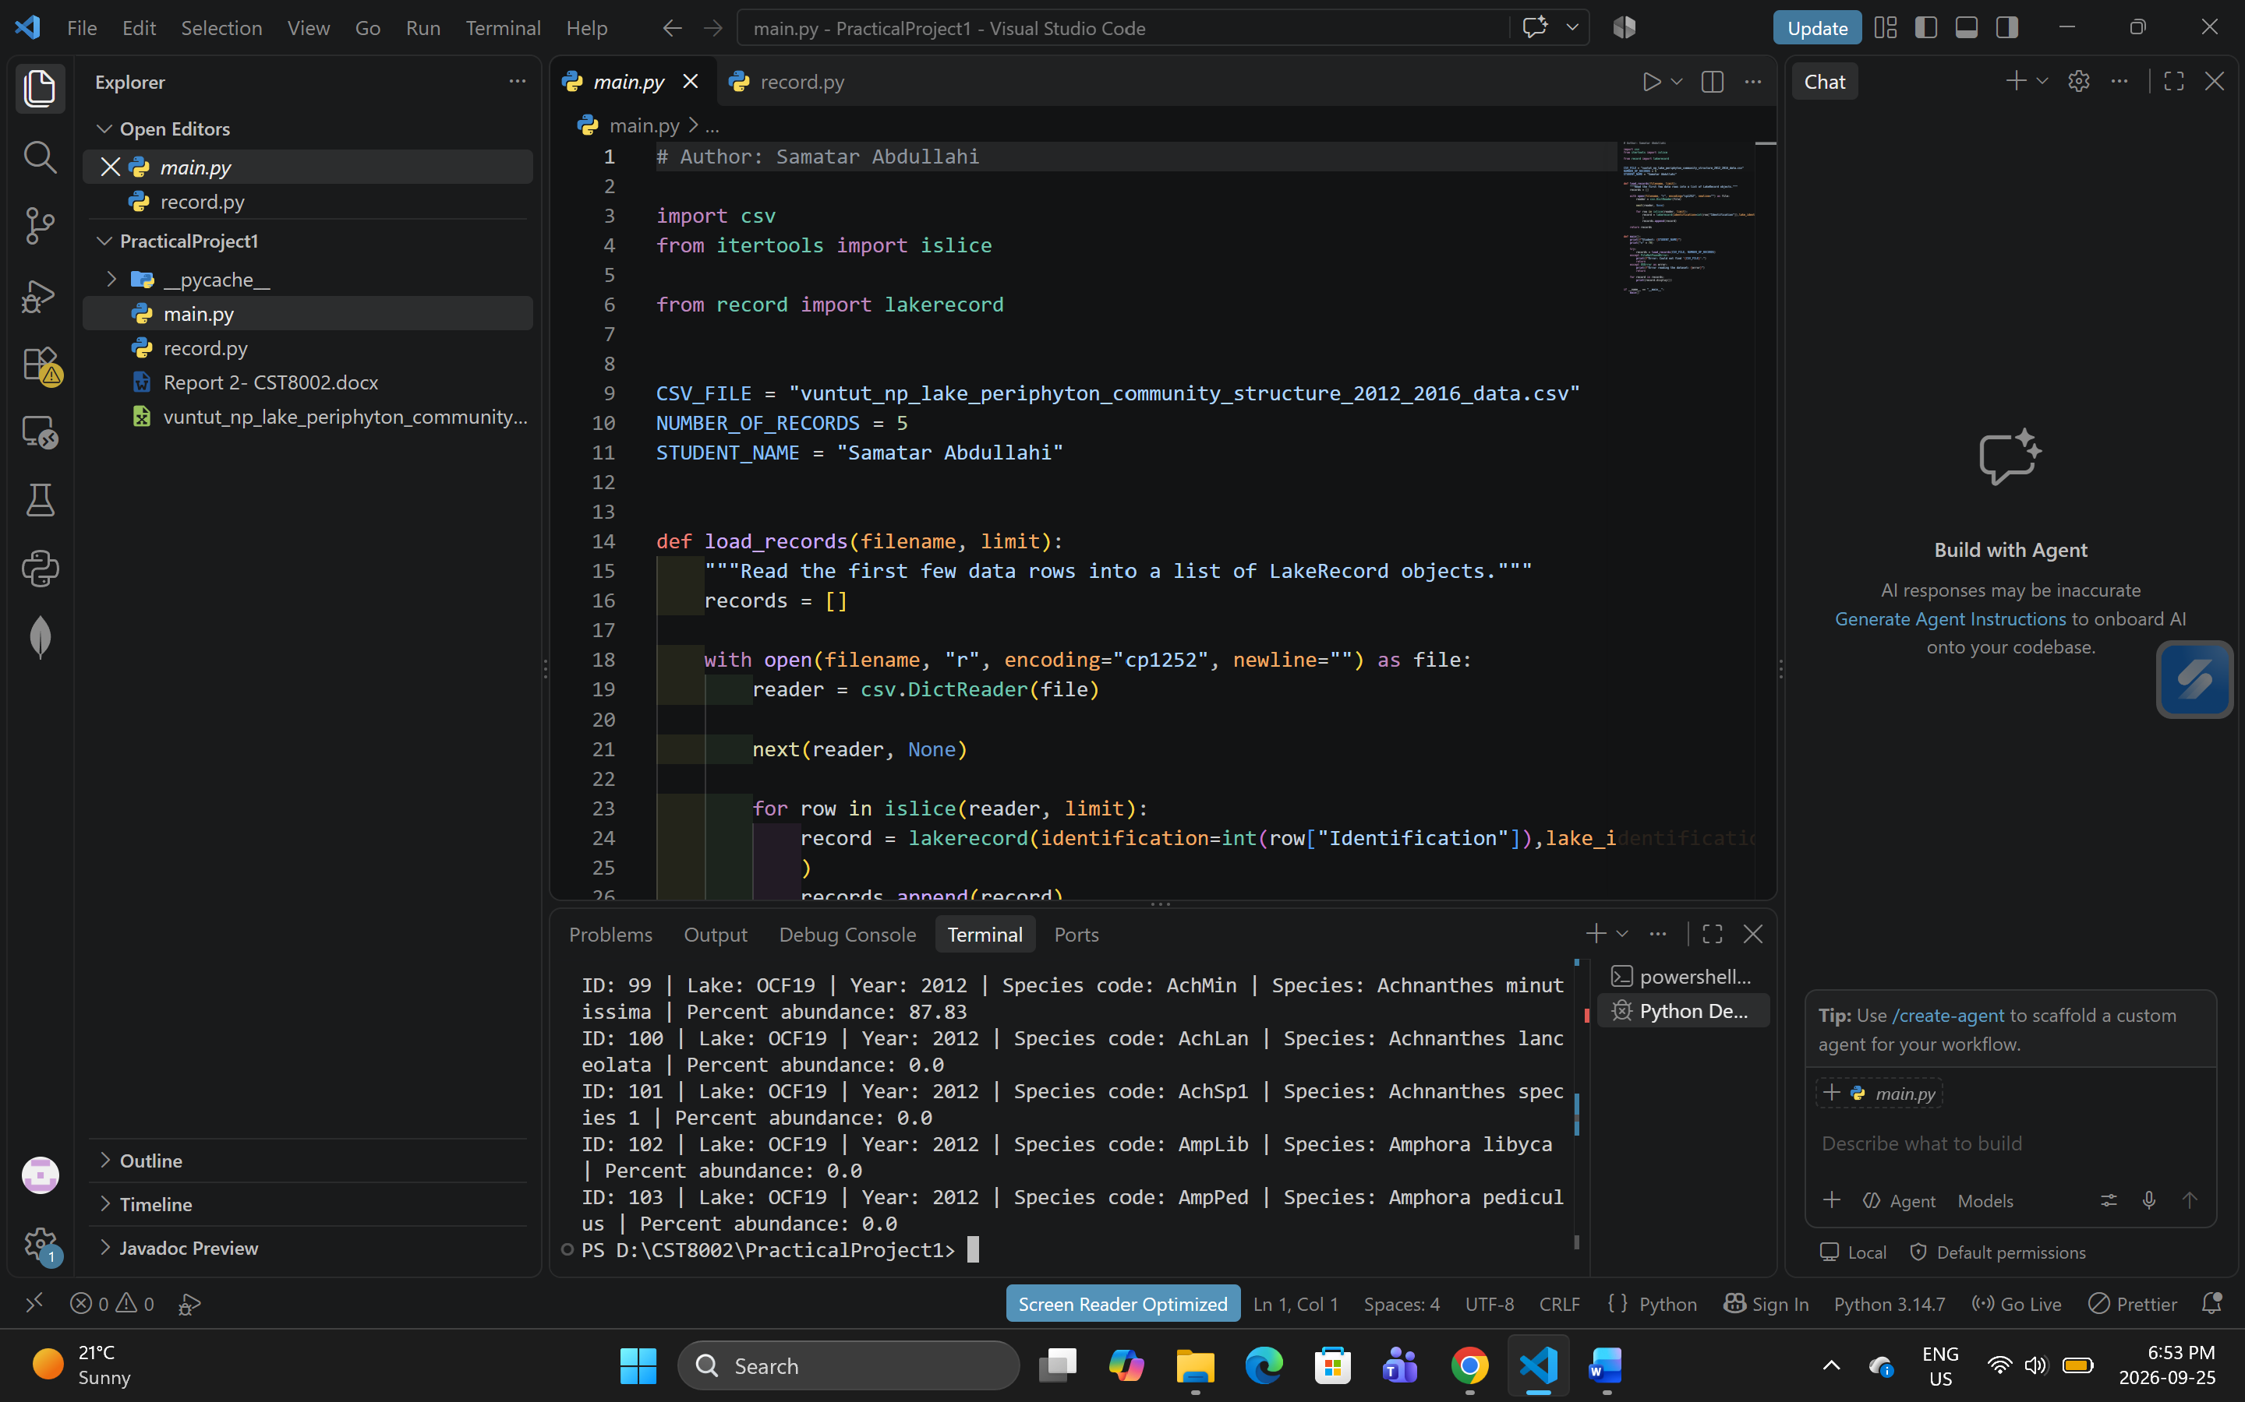
Figure 2. Highlights the layout for both files and where they are located on the machine

Github:
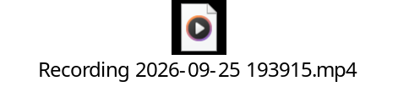

Test and Overview:

I made sure that all files were in the same folder as the main program. It displayed 5 data lines starting from 99-105. It showed species and Lake names. I also tried running the program from a different folder and the program displayed an error message.

Variables:
(self,identification,lake_identification,year,species_code,species,percent_abundance):

These are the variables used in the main program. This helps dictate what data the user will be looking through. These variables must match data provided in the dataset.

Methods:

def display(self):
"""Allows data to become more readable and return records fields"""
return (f"ID: {self.identification} | "f"Lake: {self.lake_identification} | "f"Year: {self.year} | "f"Species code: {self.species_code} | "f"Species: {self.species} | "f"Percent abundance: {self.percent_abundance}" )

This method is used to take in respected data from the dataset, then display them in a block sized table. This method has a return and takes in one parameter

Loops:

for record in records:
print(record.display())

This loop looks through a record in the records array and displays all record. In this case, we have 5 records from the respected data set.

File I/O:

with open(filename, "r", encoding="cp1252", newline="") as file:
reader = csv.DictReader(file)

next(reader, None)

Exception handling:

try:
records = load_records(CSV_FILE, NUMBER_OF_RECORDS)
except FileNotFoundError:
print(f"Error: Could not find '{CSV_FILE}'.")
return
except OSError as error:
print(f"Error reading the dataset: {error}")
return

for record in records:
print(record.display())

References:

[1]
J. Brown, “Git Branching and Merging: A Step-By-Step Guide,” Varonis.com, May 17, 2021. https://www.varonis.com/blog/git-branching-and-merging (accessed Sept. 25, 2026).

[2]
C. Schafer, “Python Tutorial: File Objects - Reading and Writing to Files,” YouTube. Apr. 29, 2016. Accessed: Sept. 25, 2026. [YouTube Video]. Available: https://www.youtube.com/watch?v=Uh2ebFW8OYM

[3]
GeeksforGeeks, “Python Docstrings,” GeeksforGeeks, June 2017. https://www.geeksforgeeks.org/python/python-docstrings/ (accessed Sept. 25, 2026).

